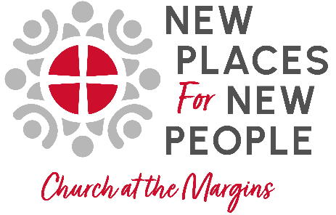
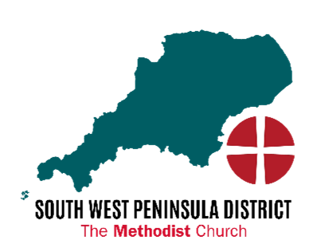
NPNP / CAM Initial Form

Initial Ideas Form:

––––––––––––––––––––––––––––––––––––––––––––––––––––––––––––––––––––

Contact Name:

E-mail:

Telephone Number:

Role:

Minister in charge:

Circuit/church

Background:
How did the idea for this new community/project come about?

Current Situation:

What, if any kinds of mission activity are already happening here? How would this new project be different?

Team:
Who is currently making these activities happen?

Next Steps:

Vision:
How do you imagine things might develop over the next five years?

Practicalities:
How might the District NPNP team and the NPNP enabler assist in getting this project started, or support what has already emerged?
Financial implications:
What, if any financial costs might be required to launch this initiative? If a grant was available how might it be used?

Church on the margins:
"The Church at the Margins strategic area of God For All is focused on equipping the Methodist Church to steward the majority of planting and pioneering resources with a faithful and preferential bias for people and communities experiencing marginalisation." In what ways does this relate to your project/community?

Return to Rev. Loraine N Mellor: loraine.mellor@swpmethodist.org.uk

Or phone for a conversation: 07468458900

